**Module : 7**

**Ansible command Line Usage :**

So when the work needs to be done in quicker and when data needs to be done in the smoother and efficient and the fast mode now we will start working on command line.

Lets start how do you use command line using following scenarios:

Ansible command line – Installing packages

The ansible command allows us to use modules to do things across one or more servers in our environment, lets begn with some examples.

First check for all ansible connectivity in our environment.

ansible all –m ping

cat /etc/ansible/hosts

ansible all –list-hosts

these are hosts we have configured n our example environment.

Now we are doing everything on command line only.

ansible redhat –s –m yum –a “pkg=htop state=latest”

ansible ubuntu –s –m apt –a “pkg=htop state=installed”

ansible ubuntu –s –m apt –a “pkg=htop state=absent”

ansible ubuntu –s –m apt –a “pkg=git state=present”

ansible ubuntu –s –m apt –a “pkg=htop state=absent”

Above commands are simple and easy to wrte easy to execute and those are very fast in execution also.Til now we have coverd about installation now we are going to deal with services.

Ansible command line – services and hosts :

The ansible command allows us to use modules to do things across one or more servers in our environment . lets begin with some examples.

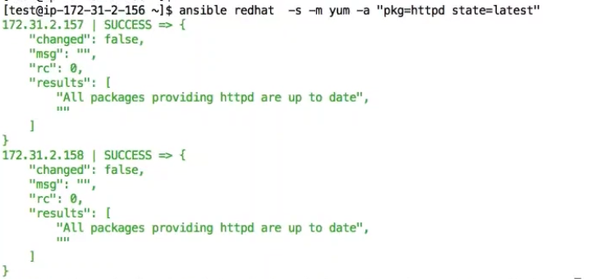

With above command we just installed httpd services in redhat group in our environment. Now am going to restart the services using below command

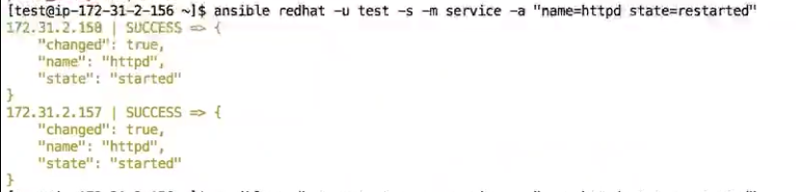

In above example we have restarted using test user with sudo access. That is why we have user module as well.

Restart is happening always when we run this command that is why we wil get always output in yellow colour only. Now if we want to stop the services means we have to do below command.

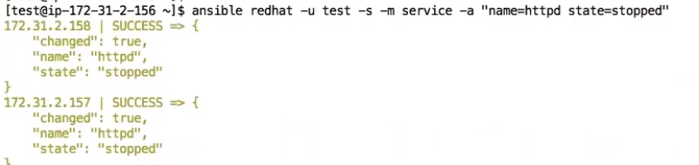

So if we want to start it again do the below command with started as state

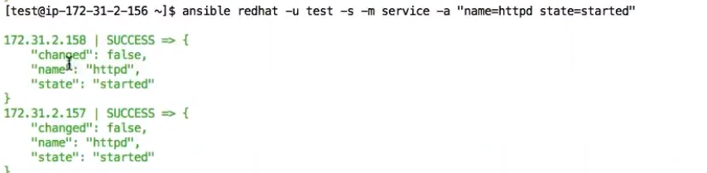

Now we are going to work on hosts.

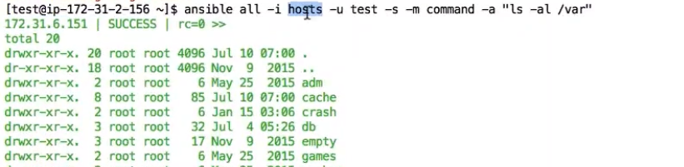

We have just used our own hosts file not from the default host files section using –I hosts command after all.

We are going to use command module in command line.

ansible appserver –u test –s –m command –a “ls –lrt /var”

This is going to display all the in /var directory on all mentioned nodes in command line

We are going to use shell module in command line with same above example

ansible appserver –u test –s –m shell –a “ls –lrt /var”

this will also do same thing lie command module.

ansible all –m ping

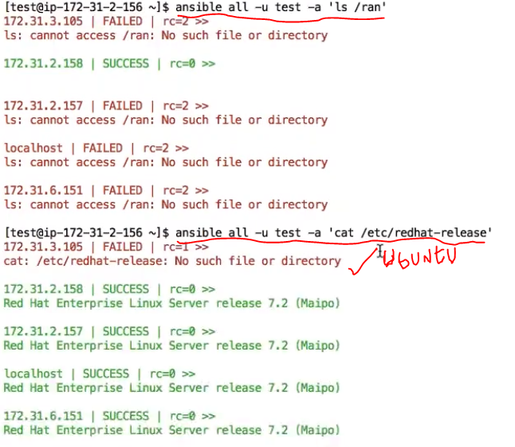

If you /etc/issue t wil give result about all nodes with Ubuntu as well.

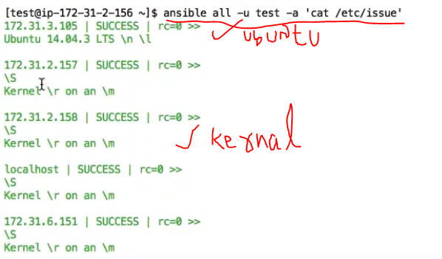

And I can df –h also to get about system memory details

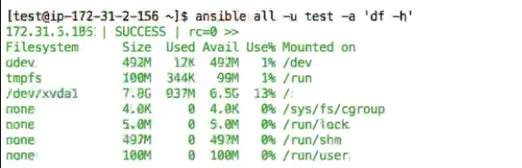

We can use some memory related commands as well like below

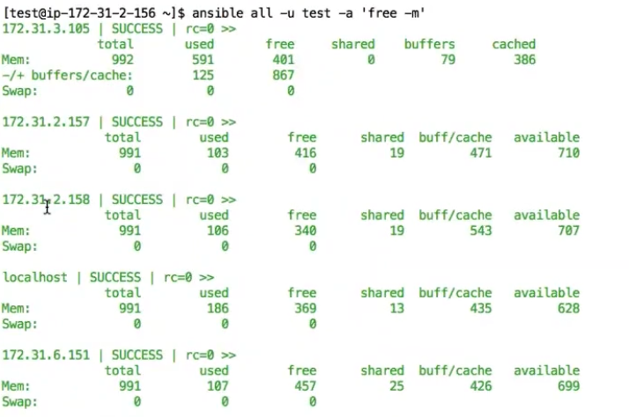

We can use some cpu usage command like below

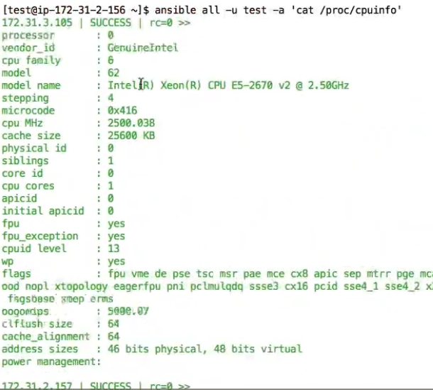

These above are like arbitrary commands

Now we are going to run about output tree:

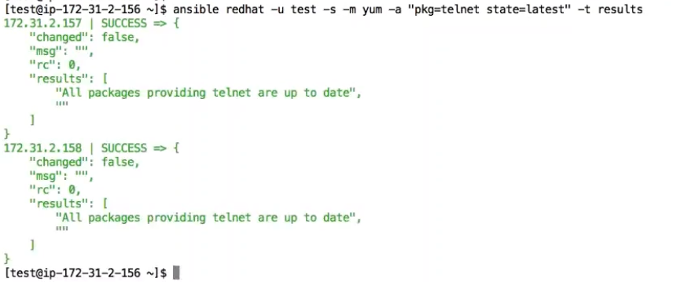

Here above example results folder gong to create under home directory go to home directory and check for the same directory.

Now we can see tree format under results.1 folder

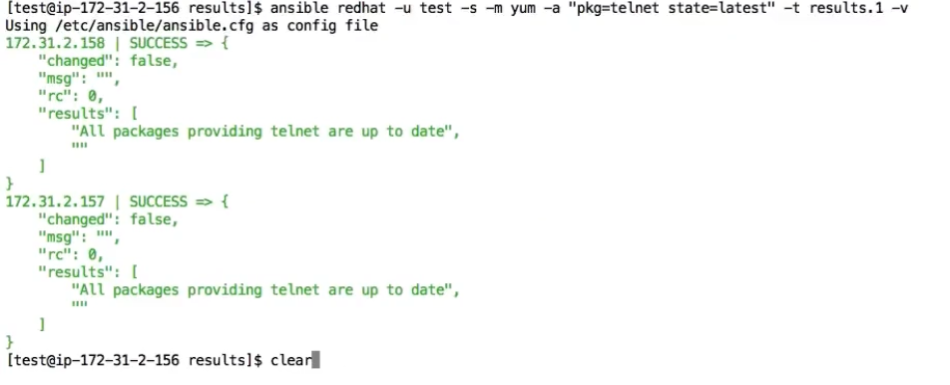

Cd

Ls –lrt

Cd results

Just check below window to check out task perfectly.

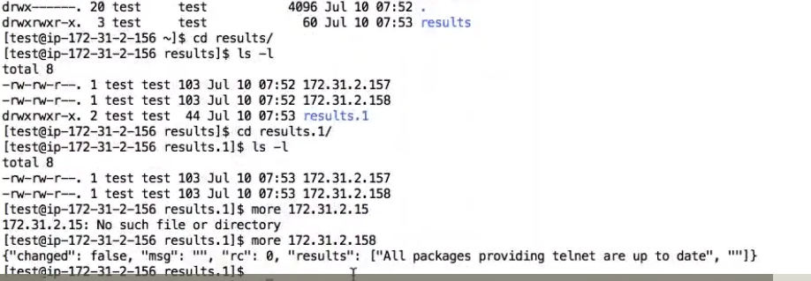

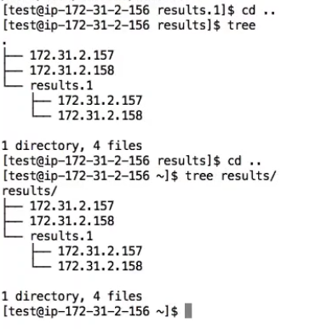

Creating users wth command lines:

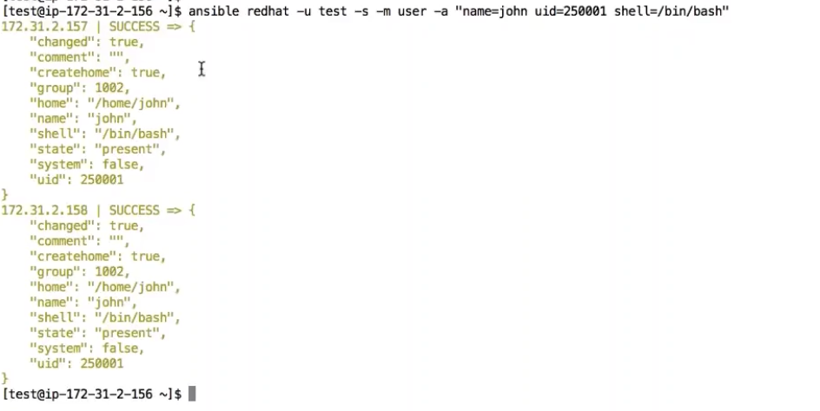

After creating users we have to go to our node systesm and type below command to check created or not.



If you want to remove the created user do the following command

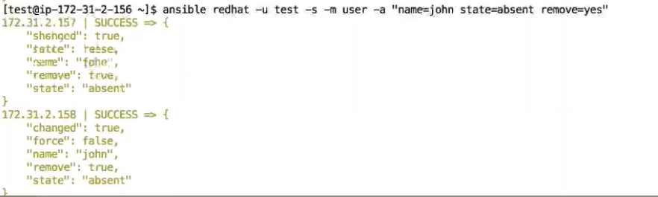

After removing users we have to go to our node systesm and type below command to check removed or not.

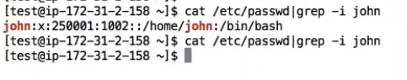Removed perfectly.

Cron jobs :

We can create like below command:

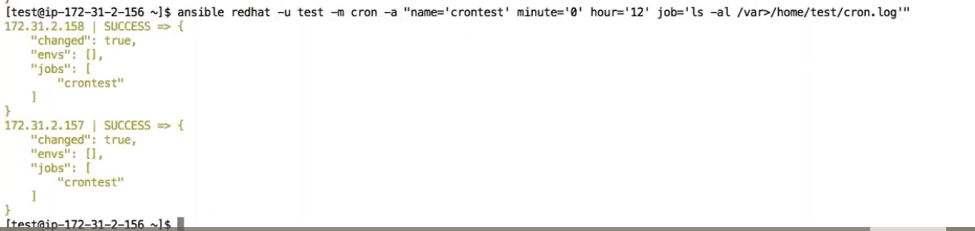

If you want to check go to all nodes and check with crontab –l command

crontab –l

If you want to remove the cron tab do below command

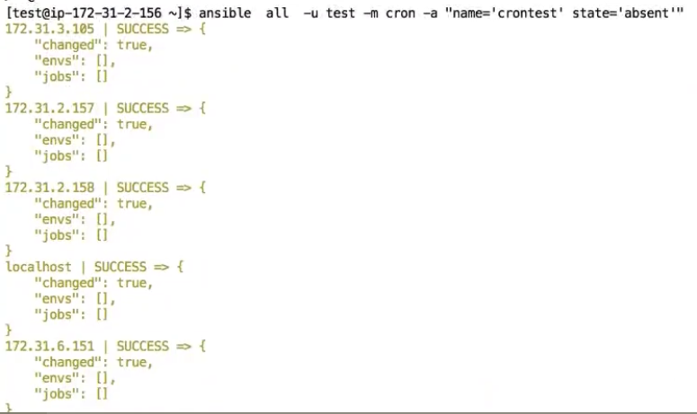

We all done with now commnd line formats. These are very fast and efficient

Module: 8

USE CASE:



There are 2 kind of executions are there one parallel and second one os serial executon.

So we are going to create 2 playbooks for types under Playboks section

Vim parallel.yml



:wq

So it is going to do the task on all nodes a t a time

Ansible-playbook parallel.yml

It is going to sleep for 5 seconds on all nodes aned executed

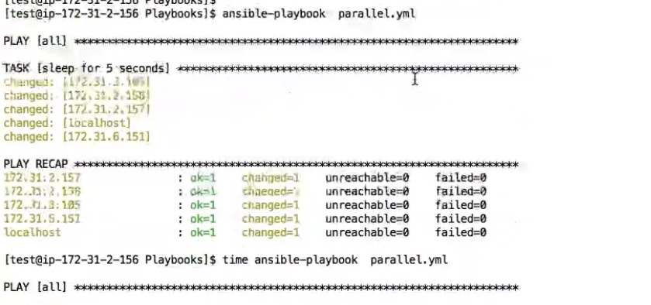

If you use time command infromt it will display about the sleep times

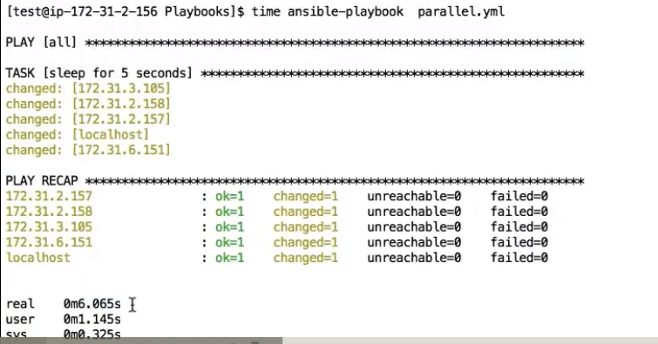

It is taking total 6 seconds.



Above image stating that the playbook is going to run parallally on all nodes and executing one by one.

But I want to execute serially like below image

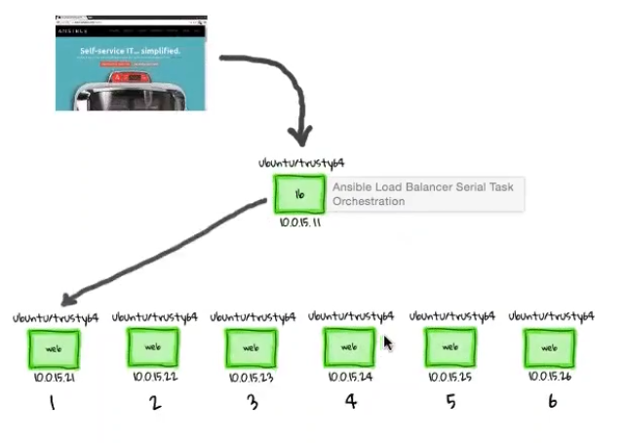

Vim serial.yml



:wq

ansible-playbook serial.yml

this playbok will do sleep for 5 minits on all nodes when you run this.

Now we are going to host websit using nginx http server like apache on all nodes.

First we have to create index.html file in our master home directory like where is means /home/test.

Then we have to copy that index.html file into target nodes and we have to install nginx web server using nginx web server we are going to host our website on all nodes.

I Have just created one program here. Here I have taken 2 index files so we are going to deploy 2 websites but based on time period first website will be hosted for 15 seconds second website wil be continued as per the example playbook.

